**DAILY ONLINE ACTIVITIES SUMMARY**

|  |  |  |  |
| --- | --- | --- | --- |
| **Date:** | 19/05/2020 | **Name:** | Krishnitha |
| **Sem & Sec** | 4th sem, A Section | **USN:** | 4AL18CS039 |
| **Online Test Summary** | | | |
| **Subject** | DESIGN AND ANALYSIS OF ALGORITHM | | |
| **Max. Marks** | 30 | **Score** | 16 |
| **Certification Course Summary** | | | |
| **Course** | 1. STEPathon-communication skills [ICT ACEDAMY] 2. "Python Workshop" -By BRAIN O VISION SOLUTIONS | | |
| **Certificate Provider** | 1) THE HINDU  2) Brain o vision solutions pvt. Ltd | **Duration:** | 1) 2 hrs.  2) 90 mins |
| **Coding Challenges** | | | |
| **Problem Statement:** A user will input two strings, and we find if one of the strings is a sub sequence of the other. Program prints “yes” if either the first string is a sub sequence of the second string or the second string is a sub sequence of the first string. Assume that, the length of the first string is smaller than or equal to the length of the second string | | | |
| **Status:** DONE | | | |
| **Uploaded the report in GitHub** | | YES | |
| **If yes Repository name** | | <https://github.com/jaslinesharontauro/lockdown_coding/blob/master/String.c> | |
| **Uploaded the report in slack** | | YES | |

Online Test Details:

Today we had assessment in the subject DESIGN AND ANALYSIS OF ALGORITHM. It was based on first module of this subject. There were total 25 number of questions of which 20 questions of 1 mark each and 5 questions of 2 marks each.

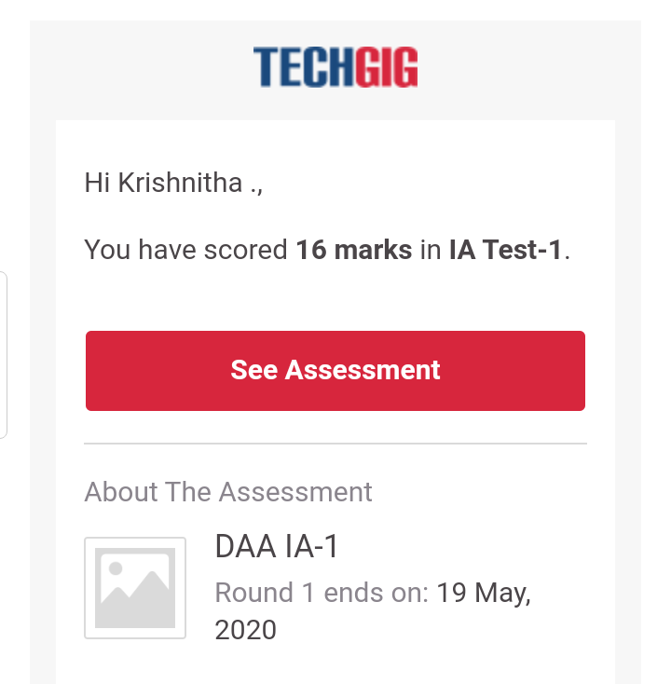

Certification Course Details:

Today I have done 2 certification courses STEPathon-communication skills

[ICT ACEDAMY]. This course based on communication skills. Today I

have   completed the 4 videos. First video was based on Introduction to

the STEPathon. Second video was a warm-up session which contained some

question based on our listening, Reading, Writing and Grammar skills. In which

my score was 8.4 out of 12 marks. And also, I completed week one 2 listening

skills videos**.**

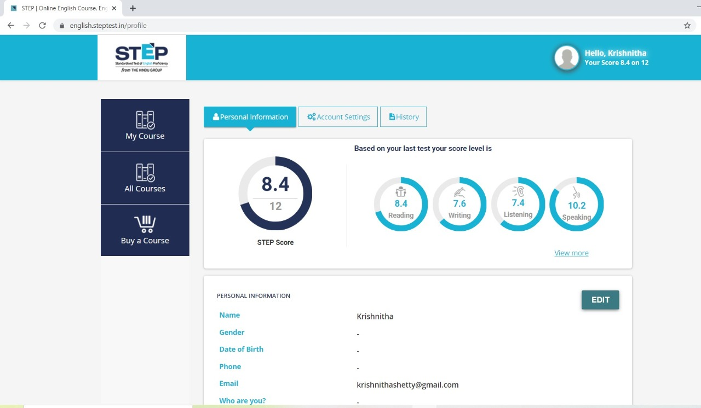

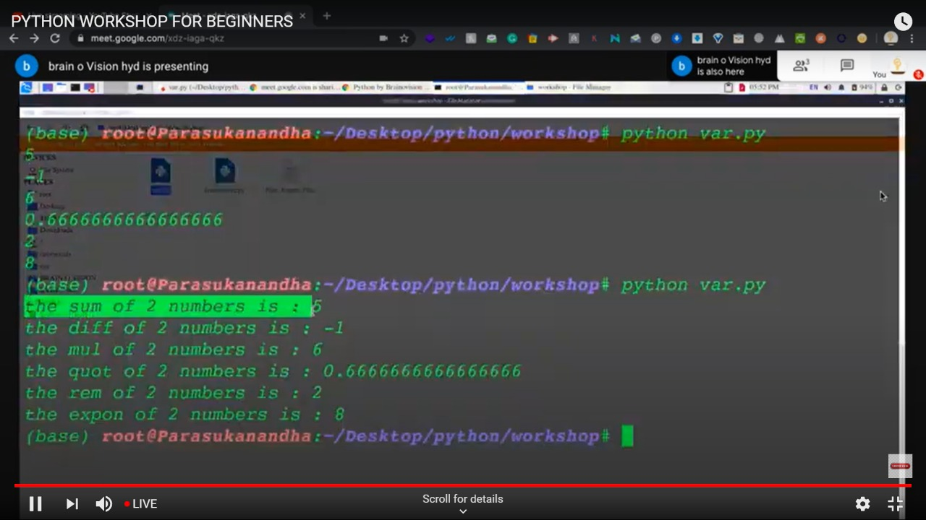

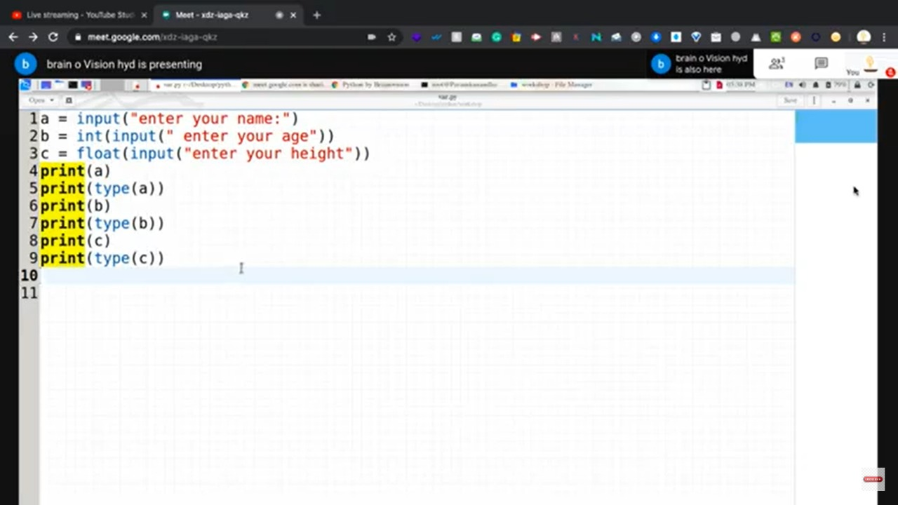

Coding Challenges Details:

Problem 1:

A user will input two strings, and we find if one of the strings is a sub sequence of the other. Program prints “yes” if either the first string is a sub sequence of the second string or the second string is a sub sequence of the first string.  
Assume that, the length of the first string is smaller than or equal to the length of the second string.

An expected output of the program:

Input the first string  
tree  
Input the second string  
Computer science is awesome  
YES

**Solution:** Uploaded it in GitHub

